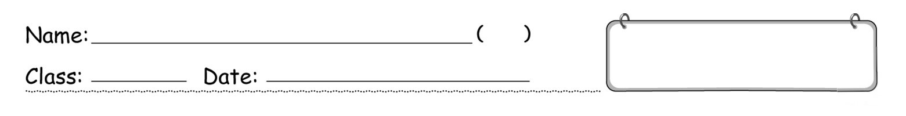

Write the correct letters (A – O) in the boxes.
A eat a roast goose B eat a roast turkey
C eat pineapple fried rice D eat rice with deep-fried pork chop
E eat sushi at a fish market F explore a cave
G go on a boat trip H go on a castle tour
I go skiing J take a ride in a hot-air balloon
K take photos with cartoon characters L visit a chocolate factory
M visit a fishing village N visit a temple
O watch a play at a theatre P look at some waterfalls
Q look at some mountains
Book 5A Chapter 6
Graded Worksheet 1

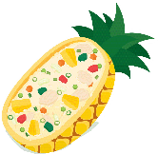
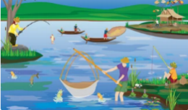
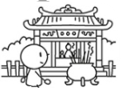
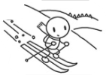
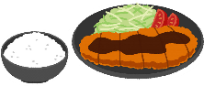
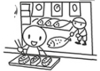
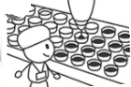
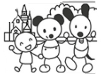
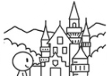
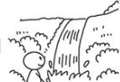
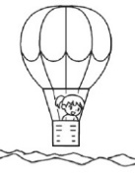
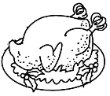
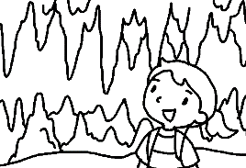
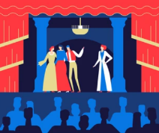
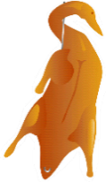
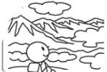
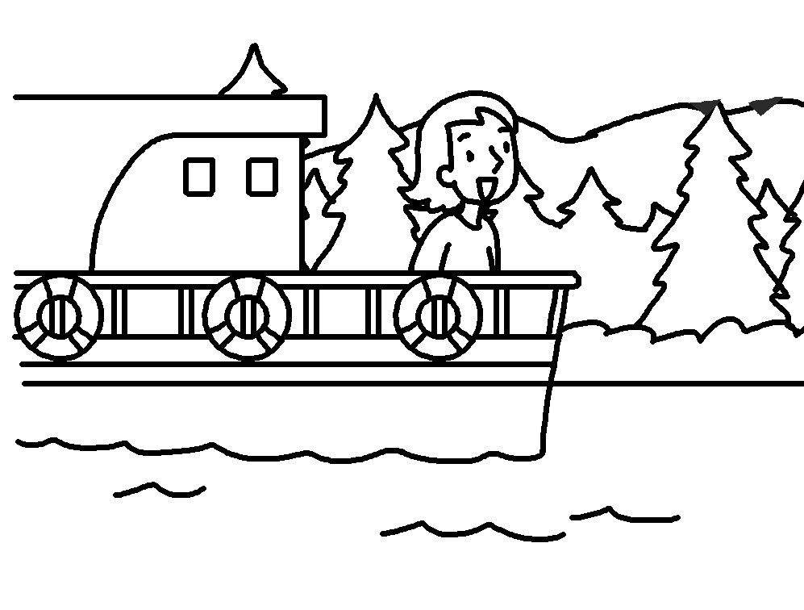
Write.
Things to do in Thailand
Things to do in Japan
Things to do in America
Things to do in China
Book 5A Chapter 6
Graded Worksheet 1

Things to do in China
❶ e_____________ a c_____________
❷ go on a b_____________ t_____________
❸ eat a r_____________ g_____________
❹ watch a p_____________ at a t_____________
❺ l___________ at some m_______________

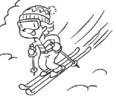
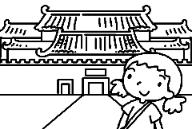
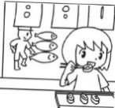
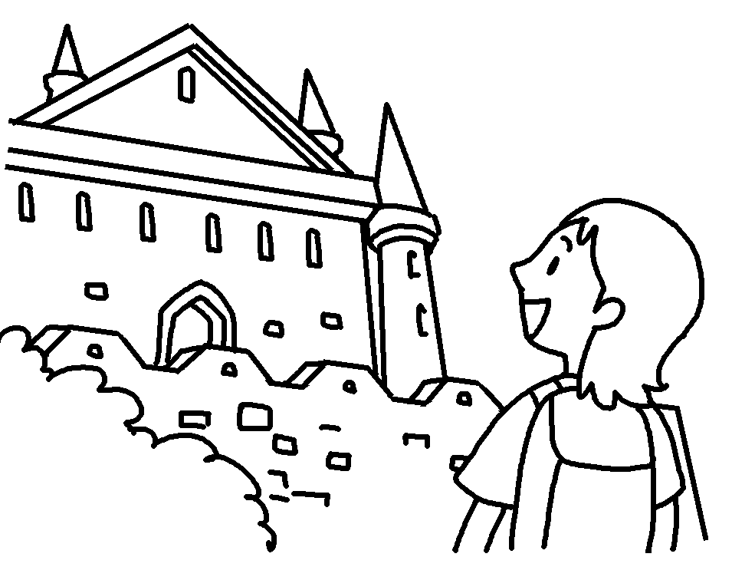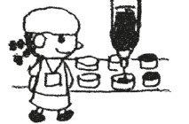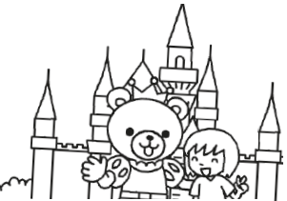
Things to do in America
❻ g_____________ on a c_____________ t_____________
❼ take a r_____________ in a h_____________ b_____________
❽ eat a r_____________ t_____________
❾ l___________ at some w_______________
Things to do in Thailand
⓯ v_____________ a t_____________
⓰ v_____________ a f_____________ v_____________
⓱ eat p_____________ f_____________ rice
Things to do in Japan
❿ take p_____________ with c_____________ c_____________
⓫ v_____________ a c_____________ f_____________
⓬ eat s_____________ at a fish m_____________
⓭ go s_____________
⓮ eat rice with d_____________ p_____________ c_____________
Fill in the blanks. Use the correct form of the verbs given.
Book 5A Chapter 6
Graded Worksheet 1

go go on explore look take eat visit watch
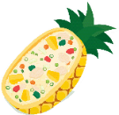
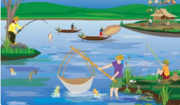
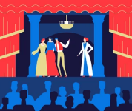
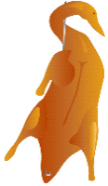
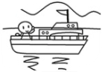
⓱
⓰
⓯
⓮
⓭
⓬
⓫
❿
I went to Thailand last summer. I ⓭___________
a ____________ and ⓮ a _____________ ___________ there. I went hiking too. I ⓯____________ _________ some _________________ and ⓰__________________ . Also, I ⓱____________ _______________ __________ _________ . It was yummy!
Laura:
Karen:
I went to America last winter. I ❿__________ on a __________ ___________ and ⓫___________ a _________ in a ___________ _____________ . I ⓬___________ a ___________ _____________ too.
It was delicious!
❾
❽
❼
❻
❺
I went to Japan last summer. I ❺___________ __________ with ___________ ____________ . I also ❻____________ a ______________ ____________ . I ❼__________ ___________ too. It was fun! I ❽_________ __________ at a __________ _____________ and ❾ rice with ________________ __________ ___________ . I loved them!
Grace:
❹
❸
❷
❶
I went to China last summer. I ❶_____________ a ___________ and ❷_____________ ________ a ___________ ___________ . I ❸_____________ a _____________ at a _____________ too. I ❹____________ a _____________ ____________ .
I enjoyed it a lot!
Joyce:

Fill in the blanks. Use the correct form of the verbs.
Book 5A Chapter 6
Graded Worksheet 1

roast goose roast turkey pineapple fried rice rice with deep-fried pork chop
sushi at a fish market explore a cave go on a boat trip go on a castle tour
go skiing visit … temple visit a fishing village watch a play at a theatre
take photos with cartoon characters take a ride in a hot-air balloon
visit a chocolate factory look at … mountains waterfalls

Winnie’s Blog
I have been to Japan three times. Three years ago I went there with my parents for the first time. We had such a great time. First we went to a theme park. I ^{1.}_______________________
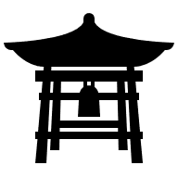
______________________ there. I love the princesses best. Then we ^{2.}_____________ a beautiful ______________ . My favourite activity was eating ^{3.}_____________________
_________________ . The seafood was so fresh. I also liked eating ^{4.}____________________
___________________ . It was very crunchy!
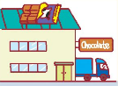
We went to Japan again last winter. This time we ^{5.}_____________________ in Hokkaido. It was cold on the snowy mountains but I loved it. We also ^{6.}____________________________
________________________________ . We bought a lot of snacks as souvenirs because they were so yummy.

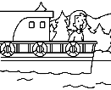
We went to Japan again this summer. This time we went to the south of Japan. We ^{7.}___________________________________________________ . The view was very beautiful from up there. We also ^{8.}__________________________________ . We swam in the beautiful water and ^{9.}________________________________ .
It was dark inside so I was a bit scared.

David’s Blog
I travelled to Canada at Christmas when I was seven. I ^{10.}______________________________
____________________ . I liked it a lot because the plot was surprising. I also ^{11.}___________
__________________________ . It was 200 years old! It was huge. On Christmas Day, we had dinner in a restaurant and I tried ^{12.}______________________ for the first time. It looked like a big chicken. It was yummy but I enjoy eating ^{13.}_____________________ in Hong Kong more.
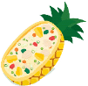
I have been to Thailand too. I ^{14.}___________________________________ there and I learnt more about fishermen’s lives. I also went hiking. I ^{15.}__________________________________ and ^{16.}_______________________. My favourite Thai dish was ^{17.}_______________________
_________________ . It was delicious!

Fill in the blanks. Use the correct form of the verbs.
Book 5A Chapter 6
Graded Worksheet 1

eat explore go on go look take visit watch

roast goose roast turkey pineapple fried rice rice with deep-fried pork chop
sushi at a fish market a cave a boat trip a castle tour
skiing a fishing village a chocolate factory temple
photos with … cartoon characters a play at a theatre a ride in a hot-air balloon

Bob : Have you ever travelled outside Hong Kong?
Ted : Yes, I have. I have been to Thailand, Japan and England.
Bob : What did you do in Thailand?
Ted : We ^{1.} ____________________________ . The water was very clean and beautiful. We
^{2.} _______________________ on a small island. It was dark inside but I wasn’t scared.
Bob : What else did you do?
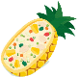
Ted : We ^{3.} _________________________ . We saw a lot of monks. People prayed for good
fortune there. I learnt to make ^{4.} _________________________ in a cooking
school too. It was fun to cook with fruit. Also, I ^{5.} ______________________________
__________________ and learnt a lot about fishermen’s lives. I went hiking too. I
^{6.}________________________________ and ^{7.}______________________ .
Bob : Interesting! What about Japan? When did you go there?
Ted : We went to Japan last Christmas. We ^{8.} _______________________ on the snowy
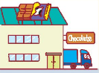
mountains. I fell a few times but it was fun. We also ^{9.} __________________________
_________________________ . Remember I gave you a box of your favourite snack? I bought it there.
Bob : Yes! It was yummy. And did you ^{10.} _______________________________________ ?
Ted : Of course! My whole family love fresh seafood, but our favourite food in Japan is
^{11.} _______________________________ . It was crunchy and yummy!
Bob : Did you go to England this summer?
Ted : Yes, we did. We did lots of things there. We ^{12.} ________________________________
______________ . The actors and actresses were great! We ^{13.} ____________________
____________________ too. Kings and queens lived there a long time ago. We also
^{14.} ____________________________________ . The view was amazing from up there.
Bob : I know you went to Sunny Amusement Park. Did you ^{15.} _____________________ the
___________________________ ?

Ted : No, I didn’t. I’m not really interested in them.

Bob: Did you try ^{16.} _____________________________ ?

Ted: No, I didn’t. It wasn’t Christmas so it was hard to find. One afternoon, my mum missed Chinese food so we ate ^{17.} ______________________ in China Town.

Book 5A Chapter 6 Graded Worksheets
Worksheet 1★
ANSWERS
1 F 2 G 3 Q 4 A 5 O
6 P 7 H 8 J 9 B 10 K
11 L 12 E 13 I 14 D 15 N
16 M 17 C

Worksheet 1★★
1 explore a cave
2 go on a boat trip
3 eat a roast goose
4 watch a play at a theatre
5 look at some mountains
6 go on a castle tour
7 take a ride in a hot-air balloon
8 eat a roast turkey
9 look at some mountains
10 take photos with cartoon characters
11 visit a chocolate factory
12 eat sushi at a fish market
13 go skiing
14 eat rice with deep-fried pork chop
15 visit a temple
16 visit a fishing village
7 eat pineapple fried rice
Worksheet 1★★★
ANSWERS
1 explored a cave
2 went on a boat trip
3 watched a play at a theatre
4 ate a roast goose
5 took photos with cartoon characters
6 visited a chocolate factory
7 went skiing
8 ate sushi at a fish market
9 rice with deep-fried pork chop
10 went on a castle tour
11 took a ride in a hot-air balloon
12 ate a roast turkey
13 visited a temple
14 a fishing village
15 looked at ... mountains
16 waterfalls
17 ate pineapple fried rice

Worksheet 1★★★★
1 took photos with cartoon characters
2 visited ... temple
3 sushi at a fish market
4 rice with deep-fried pork chop
5 went skiing
6 visited a chocolate factory
7 took a ride in a hot-air balloon
8 went on a boat trip
9 explored a cave
10 watched a play at a theatre
11 went on a castle tour
12 roast turkey
13 roast goose
14 visited a fishing village
15 looked at some mountains
16 waterfalls
17 pineapple fried rice
Worksheet 1★★★★★
ANSWERS
1 went on a boat trip
2 explored a cave
3 visited a temple
4 pineapple fried rice
5 visited a fishing village
6 looked at some mountains
7 waterfalls
8 went skiing
9 visited a chocolate factory
10 eat sushi at a fish market
11 rice with deep-fried pork chop
12 watched a play at a theatre
13 went on a tour at a castle
14 took a ride in a hot-air balloon
15 take photos with ... cartoon characters
16 roast turkey
17 roast goose

