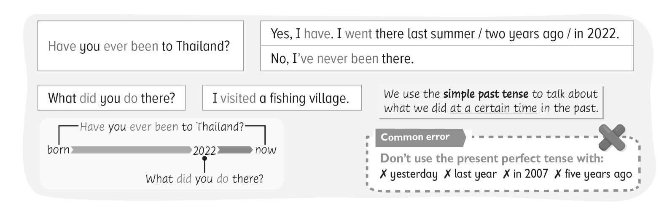


The children are talking about the places they have visited. Finish what they say.
explore a cave eat sushi at a fish market visit a chocolate factory
go skiing take a ride in a hot-air balloon go on a boat trip
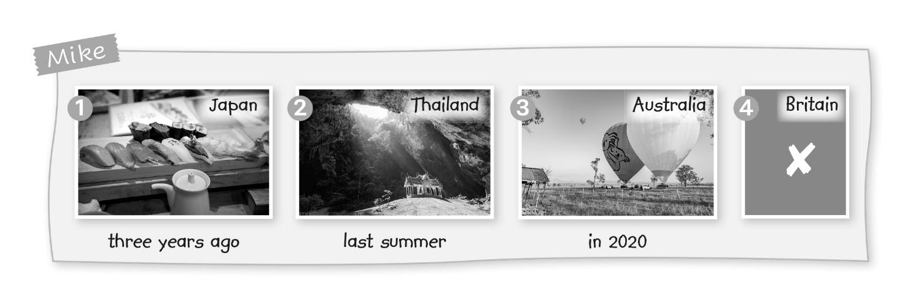

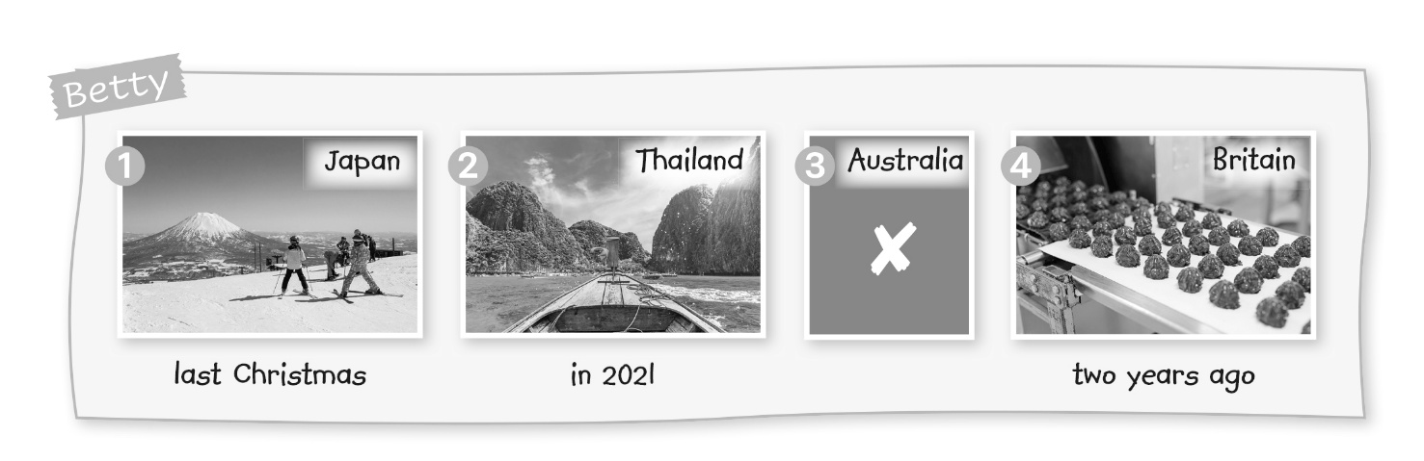

1 | Betty | : Have you ever been to Japan?
 | Mike | : Yes, I have. I went there __________________________ .
 | Betty | : What did you do there?
 | Mike | : I __________________________________________ . How about you? Have you ___________________ to Japan?
 | Betty | : Yes, I have. I _____________________________________ .
 | Mike | : What ____________________________ ?
 | Betty | : I _________________________________________________________ .

2 | Betty | : Have you _________________________________ ?
 | Mike | : Yes, ____________ . I went ________________________________ .
 | Betty | : What __________________________ ?
 | Mike | : I __________________________________________ . How about you? Have _____________________________________ ?
 | Betty | : Yes, ____________ . I went ________________________________ .
 | Mike | : What ____________________________ ?
 | Betty | : I _________________________________________________________ .

3 | Betty | : Have __________________________________________ ?
 | Mike | : _________________ . I ______________________________________ .
 | Betty | : What __________________________ ?
 | Mike | : I ___________________________________ . How ________________ ?  Have _____________________________________ ?
 | Betty | : No, ____________________________ .

4 | Betty | : __________________________________________ ?
 | Mike | : ___________________________________ . How ________________ ?  Have _____________________________________ ?
 | Betty | : Yes, ____________ . I went ___________________________________ .
 | Mike | : What ____________________________ ?
 | Betty | : __________________________________________________________ .
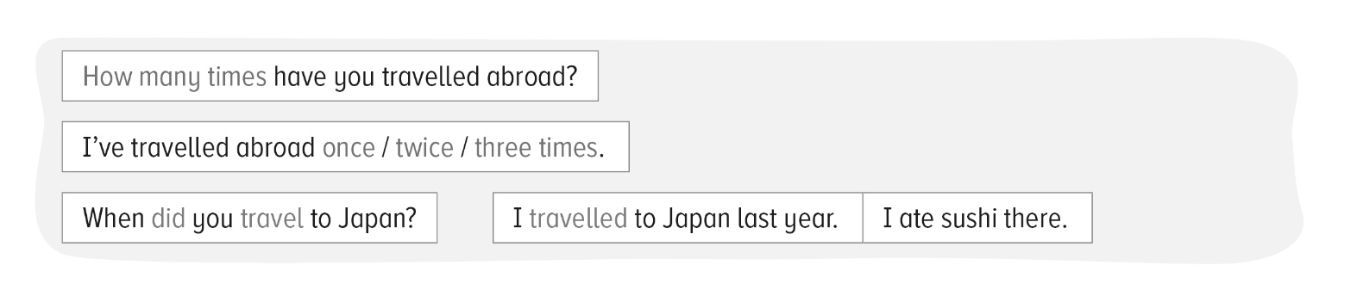


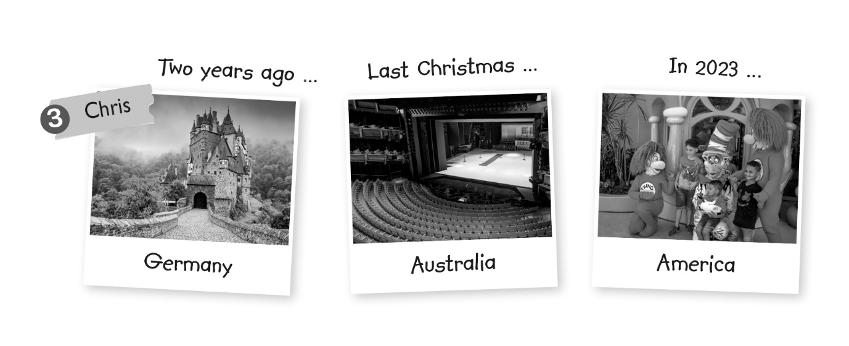
Alice is finding out about her classmates’ travel experiences. Finish what they say.
go on a castle tour visit a temple take photos with cartoon characters
look at some waterfalls visit a fishing village watch a play at a theatre
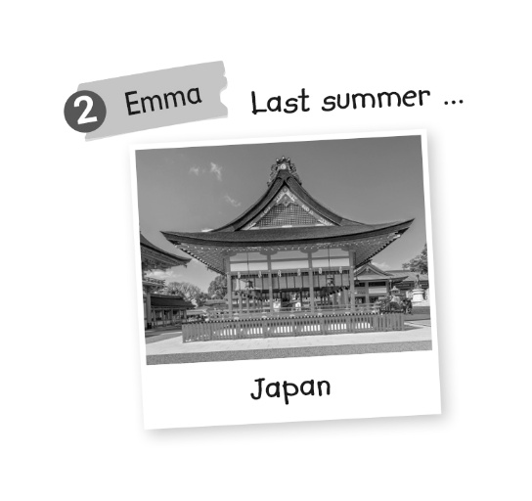
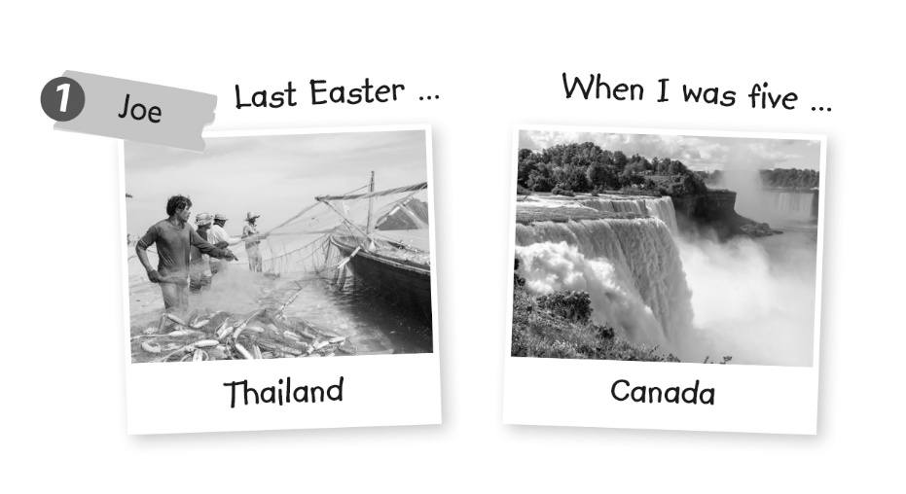

1 | Alice | : How many times have you travelled abroad?
 | Joe | : I’ve travelled abroad twice. I’ve been to __________ and __________ .
 | Alice | : When did you travel to __________ ?
 | Joe | : I travelled to ____________________________ . I visited ______________________ there.
 | Alice | : When did you travel to __________ ?
 | Joe | : I travelled to ____________________________ . I ___________________  __________________________________________________________ .
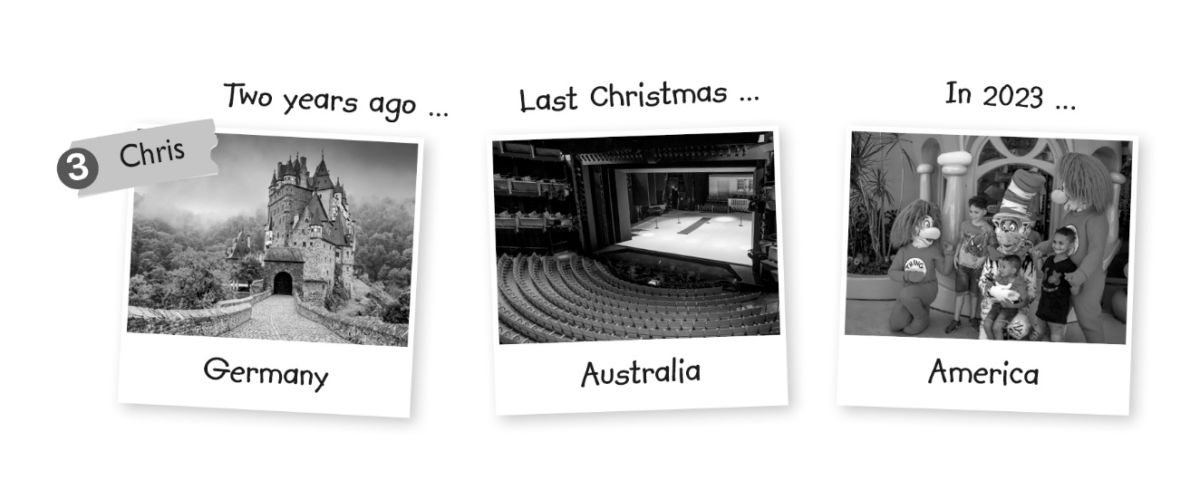
2 | Alice | : How many ________________________________________ ?
 | Emma | : I’ve ____________________________. I’ve ______________________ .
 | Alice | : When ____________________________________ ?
 | Emma | : I _______________________________________ . I ________________ ___________________________ .

3 | Alice | : ___________________________________________________ ?
 | Chris | : ____________________________________________ .  _________________________ , __________ and __________ .
 | Alice | : When ____________________________ ?
 | Chris | : I __________________________________________ . I ______________ ____________________________ .
 | Alice | : When ____________________________ ?
 | Chris | : I __________________________________________ . I ______________ _____________________________ .
 | Alice | : _______________________________________?
 | Chris | : I __________________________________________ . I ______________ _____________________________ .

Answer Key
Grammar 1
1 | Betty | : Have you ever been to Japan?
 | Mike | : Yes, I have. I went there three years ago .
 | Betty | : What did you do there?
 | Mike | : I ate sushi at a fish market . How about you? Have you ever been to Japan?
 | Betty | : Yes, I have. I went there last Christmas .
 | Mike | : What did you do there ?
 | Betty | : I went skiing .

2 | Betty | : Have you ever been to Thailand ?
 | Mike | : Yes, I have . I went there last summer .
 | Betty | : What did you do there ?
 | Mike | : I explored a cave . How about you? Have you ever been to Thailand ?
 | Betty | : Yes, I have . I went there in 2021 .
 | Mike | : What did you do there ?
 | Betty | : I went on a boat trip .

3 | Betty | : Have you ever been to Australia ?
 | Mike | : Yes, I have . I went there in 2020 .
 | Betty | : What did you do there ?
 | Mike | : I took a ride in a hot-air balloon . How about you ?  Have you ever been to Australia ?
 | Betty | : No, I’ve never been there .

4 | Betty | : Have you ever been to Britain ?
 | Mike | : No, I’ve never been there . How about you ?  Have you ever been to Britain ?
 | Betty | : Yes, I have . I went there two years ago .
 | Mike | : What did you do there ?
 | Betty | : I visited a chocolate factory .

Grammar 2
1 | Alice | : How many times have you travelled abroad?
 | Joe | : I’ve travelled abroad twice. I’ve been to Thailand and Canada .
 | Alice | : When did you travel to Thailand ?
 | Joe | : I travelled to Thailand last Easter . I visited a fishing village there.
 | Alice | : When did you travel to Canada ?
 | Joe | : I travelled to Canada when I was five . I looked at some waterfalls there .

2 | Alice | : How many times have you travelled abroad ?
 | Emma | : I’ve travelled abroad once . I’ve been to Japan .
 | Alice | : When did you travel to Japan ?
 | Emma | : I travelled to Japan last summer . I visited a temple there .

3 | Alice | : How many times have you travelled abroad ?
 | Chris | : I’ve travelled abroad three times .  I’ve been to Germany , Australia and America .
 | Alice | : When did you travel to Germany ?
 | Chris | : I travelled to Germany two years ago . I went on a castle tour there.
 | Alice | : When did you travel to Australia ?
 | Chris | : I travelled to Australia last Christmas . I watched a play at a theatre there.
 | Alice | : When did you travel to America ?
 | Chris | : I travelled to America in 2023 . I took photos with cartoon characters there .

