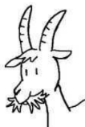
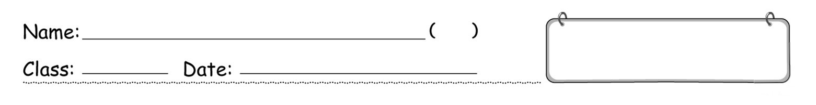

Match the pictures with the correct words.
Book 1B Chapter 4
Graded Worksheet 1

1 | 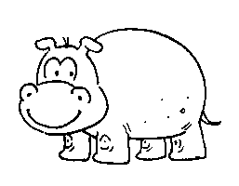 |  |  |  | a tiger
2 | 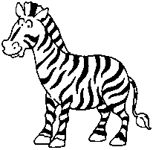 |  |  |  | an elephant
3 | 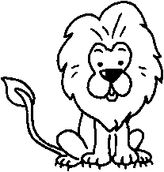 |  |  |  | a lion
4 | 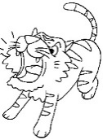 |  |  |  | a giraffe
5 | 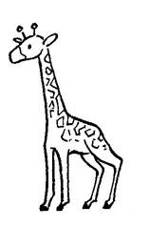  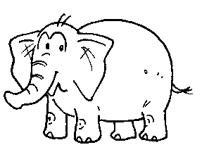 |  |  |  | a panda
6 |  |  |  |  | a neck
7 | 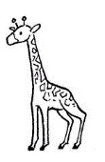 |  |  |  | wings
8 |  |  |  |  | a monkey
9 | 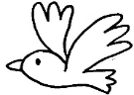 |  |  |  | a tail
10 | 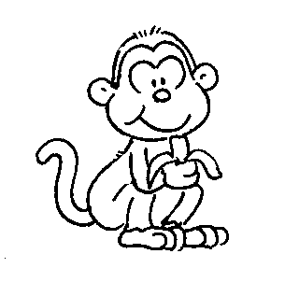 |  |  |  | a hippo
11 | 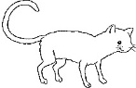 |  |  |  | horns
12 | 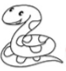 |  |  |  | a zebra
13 |  |  |  |  | a snake

Circle the words and write.
Book 1B Chapter 4
Graded Worksheet 1

1 |  |  |  | 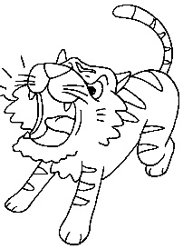  5
  a | n | b | l | i | o | n | c
  z | d | f | g | y | e | a | n
  e | l | e | p | h | a | n | t
  b | w | e | r | y | h | o | i
  r | h | i | p | p | o | o | g
  a | e | r | v | b | n | r | e
  w | q | n | e | c | k | m | r
2 |  |  | 6
3 |  |  | 6

1 | a _____________ | 2 | a _____________ | 3 | ___ ___________
4 | ___ ___________ | 5 ___ _____________ 6 ____ __________

 |  | 7 |  |  |  |  |  | 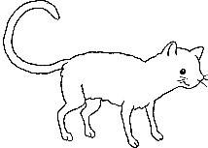  a  11
  s | a | b | a | p | a | n | d | w | m
  n | g | i | r | a | f | f | e | i | h
  a | t | a | s | n | a | b | e | n | o
  k | a | a | s | d | f | u | r | g | r
  e | i | s | o | a | k | e | o | s | n
  t | l | m | o | n | k | e | y | a | s
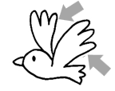
8
 | 9 |  | 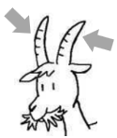  10 |  |  | 12  13
7 ___ ___________ 8 ___ ___________ 9 ___________
10 ___________ 11 ___ ___________ 12 ___ ___________
13 ___ ___________

Complete the crossword puzzle.
Book 1B Chapter 4
Graded Worksheet 1

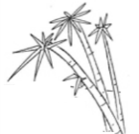
❶ A _____ is very tall. It is brown. It has a long ❷ _____ .
❸ A _____ is fat. It is black and white. It likes bamboo leaves.
❹ A _____ looks like a cat. It has black and orange fur . It can run fast.
❺ An _____ is big and grey. It has big ears and big feet.
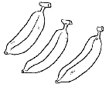
❻ A _____ can climb. It likes bananas. It has a long ❼ _____ .
❽ A bird has two _____ .
❾ A _____ is black and white. It has four long legs.
❿ A _____ is big and brown. It has a big head.
⓫ A _____ is big and grey. It has small ears and short legs. It can swim.
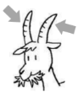
⓬ A _____ is long and thin. It has no feet.
⓭ A goat has two _____ . They are sharp.
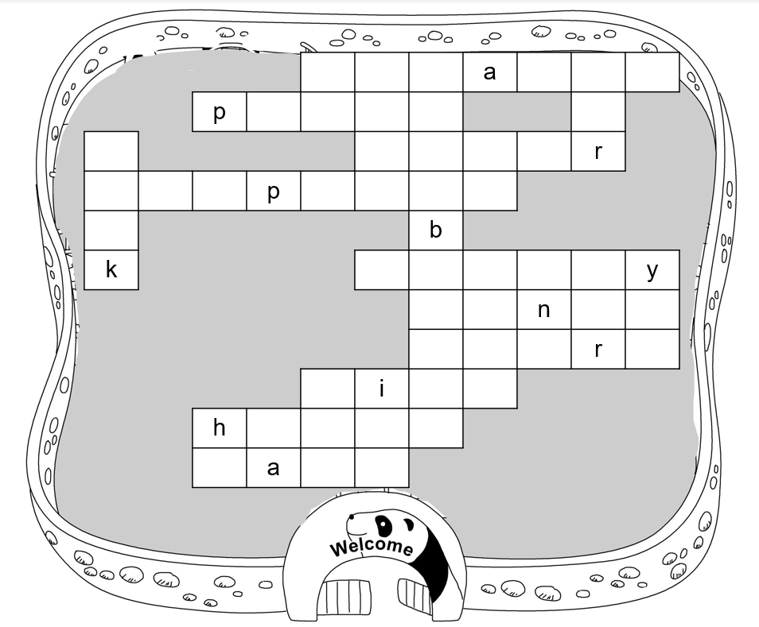
❶

❸
⓭
❷
❹
❺

⓬
❻

❽
❾
❿

⓫
❼

What is the name of the zoo?
_______________ _________

Alan and Bonnie are in a toy shop. Finish their conversation.
Book 1B Chapter 4
Graded Worksheet 1

A = Alan B = Bonnie
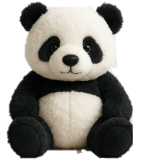
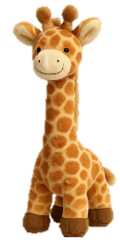
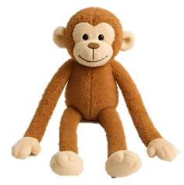
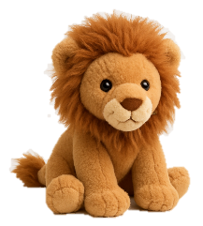
❸
❹
❻
❶
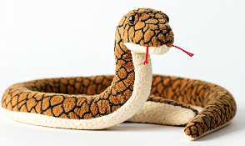
❷
❺

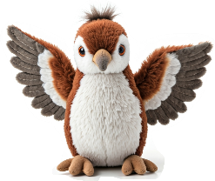
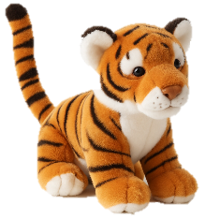
⓭
⓭
⓬
⓫
❾
❼
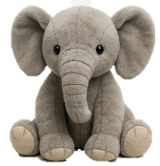
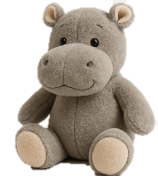
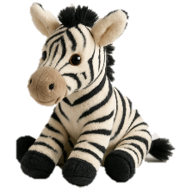
❿

A: The toy animals in this shop are cute. Look at this ^{1.}____________ . It has a big head. Oh, this ^{2.}____________ is long. It looks cool!

B: This ^{3.}____________ is very cute too. It is small and fat.

A: Look at this ^{4.}____________ . It has small eyes. I love its long ^{5.}____________ .

B: I like this ^{6.}____________ . It has long legs and arms. I like this ^{7.}____________ too. I want to put it on my bed.

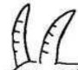
A: Are those ^{8.}____________ on its head?

B: No, those are its ears.

A: I see. This ^{9.}____________ has a long nose. I like its big ears. I like this ^{10.}____________ too. It has a big head and a big mouth.

B: Can you see the ^{11.}____________ on the shelf? It has a long ^{12.}____________ . That bird is cute too. It has big ^{13.}____________ .

A: Yes, I can see it. All these toy animals are lovely. Let’s come back to this shop again soon.

Anna and Ben are in a zoo. Finish their conversation.
Book 1B Chapter 4
Graded Worksheet 1

A = Alan B = Bonnie

A: Look at that fat ^{1.} p__________ there. It is so cute. I love its black and white fur.

B: Yes, I love its small black ears. Look at that ^{2.} g__________ . It is very tall. Its ^{3.} n__________ is very long.

A: It is beautiful. Can you see the ^{4.} l__________ over there? It is the king of the jungle. It has a big head and a big mouth.

B: It looks scary. That ^{5.} t__________ looks scary too. It has a big head and a long ^{6.} t__________ . It can run very fast.

A: Also, the ^{7.} s__________ over there is scary. It is long and it has no feet.

A: Let’s go to the pond over there. Look! There is a ^{8.} h__________ in the pond. It is grey and it has small ears.

B: There is an ^{9.} e______________ near the pond. It has a very long nose. It has big ears too.

A: There is an animal in the tree. What is it? It is brown. It can climb trees. It has no ^{10.} h__________ .

B: That is a ^{11.} m__________ . It moves very fast. Look, there is a bird in the tree too. It has big ^{12.} w__________ .

A: Oh! I like that ^{13.} z__________ under the tree. The black and white stripes on its body are beautiful.

Book 1B Chapter 4 Graded Worksheets
ANSWERS
Worksheet 1★
1 a hippo
2 a zebra
3 a lion
4 a tiger
5 an elephant
6 a neck
7 a giraffe
8 a panda
9 wings
10 a monkey
11 a tail
12 fur

Worksheet 1★★
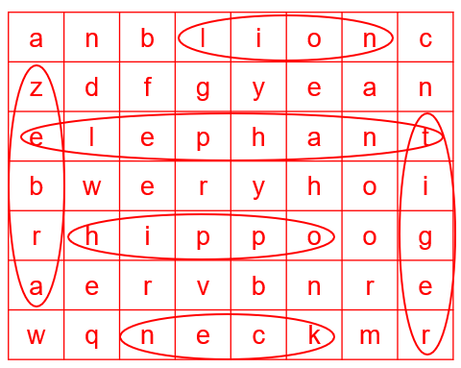
1 a hippo 2 a zebra 3 a lion 4 a tiger 5 an elephant 6 a neck
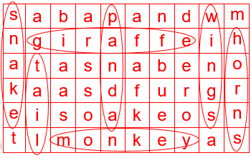
7 a giraffe 8 a panda 9 wings 10 horns
11 a monkey 12 a tail 13 a snake

Worksheet 1★★★
ANSWERS
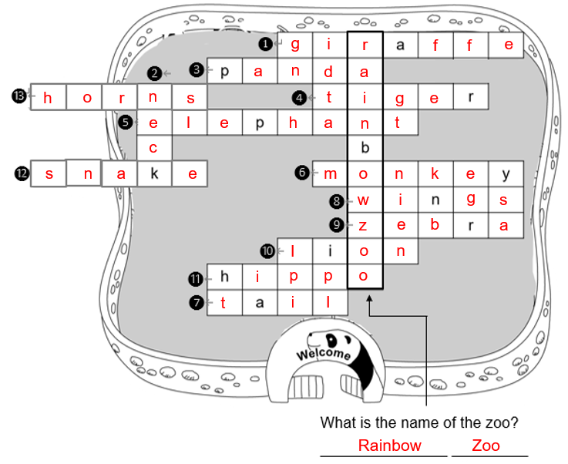

Worksheet 1★★★★
1 lion 2 snake 3 panda
4 giraffe 5 neck 6 monkey
7 zebra 8 horns 9 elephant
10 hippo 11 tiger 12 tail 13 wings

Worksheet 1★★★★★
1 panda 2 giraffe 3 neck
4 lion 5 tiger 6 tail
7 snake 8 hippo 9 elephant
10 horns 11 monkey 11 wings 13 zebrae

