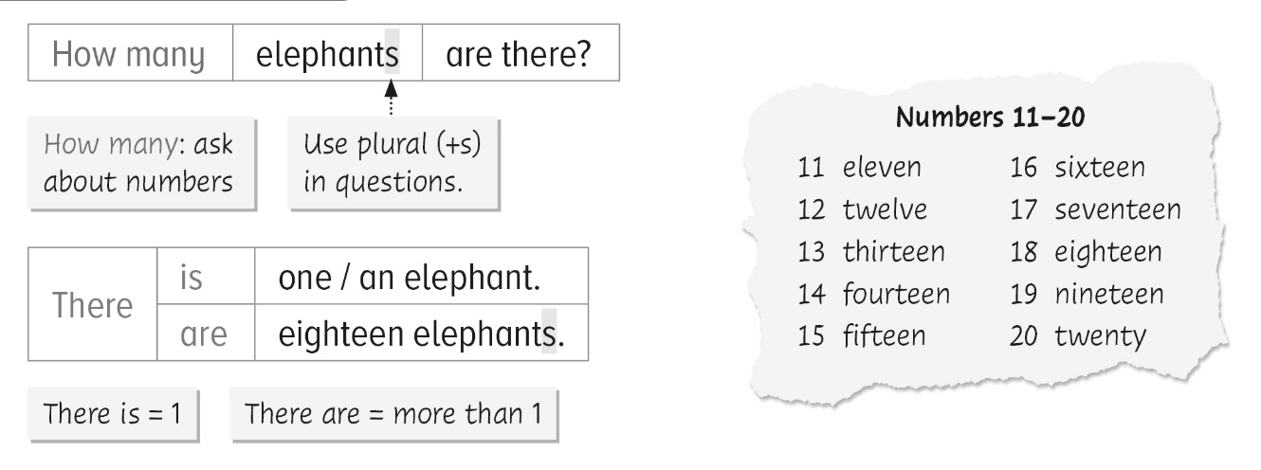


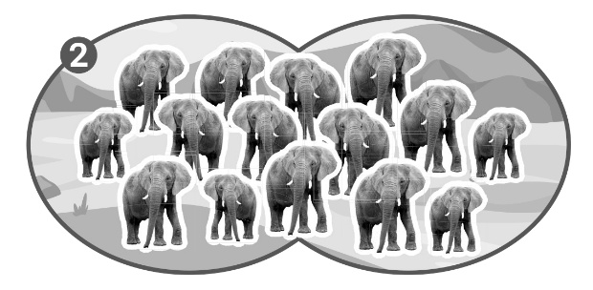
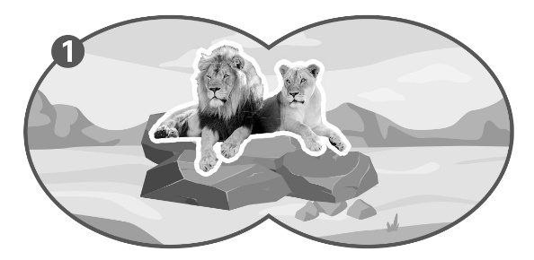
The children are counting the animals in a safari park. Finish what they say.

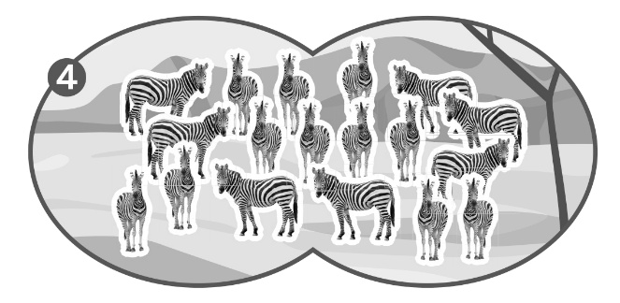
1 | James  Lily | :  : | How many lions are there?  There are __________ ________ .
2 | James  Lily | :  : | How many ________________ are there?  There are ____________ _______________ .
3 | James  Lily | :  : | How many ____________ ______ ________?  ________ ______ __________ ____________ .
4 | James  Lily | :  : | ______ ______ ____________ ______ ________?  ________ ______ ___________ ____________ .
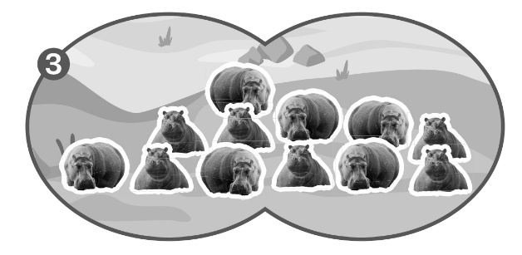


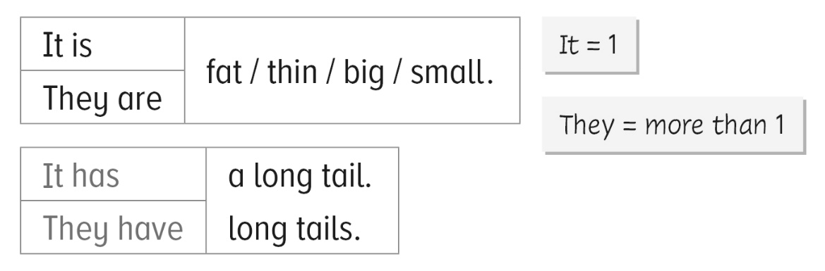

The children are talking about the animals in Happy Zoo. Finish what they say.
big tall small
long thin small
ear neck tail

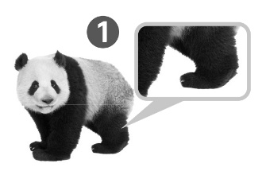 | Look at the panda. It is fat. It _______ short legs.
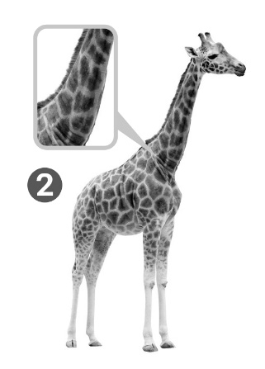 | Look at the giraffe. It __________________ . It __________________________________ .  Look at the monkeys. They are __________ . They _______________________________ .
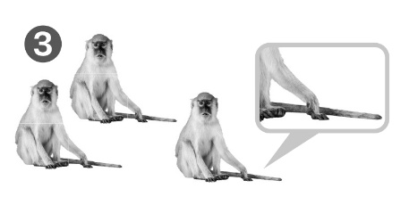

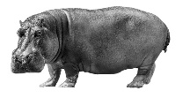  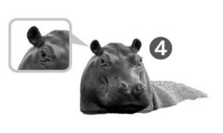 | Look at the hippos. They _______________ . ___________________________________ .
Answer Key
Grammar 1
1 James : How many lions are there?
Lily : There are two lions.
2 James : How many elephants are there?
Lily : There are fifteen elephants.
3 James : How many hippos are there?
Lily : There are twelve hippos.
4 James : How many zebras are there?
Lily : There are eighteen zebras.

Grammar 2
- Look at the panda. It is fat. It has short legs.
- Look at the giraffe. It is tall. It has a long neck.
- Look at the monkeys. They are small. They have thin tails.
- Look at the hippos. They are big. They have small ears.

