
Values Worksheet
Follow the rules
Book 1B Ch 4
Let’s think about this. Blacken the circle of your answer.
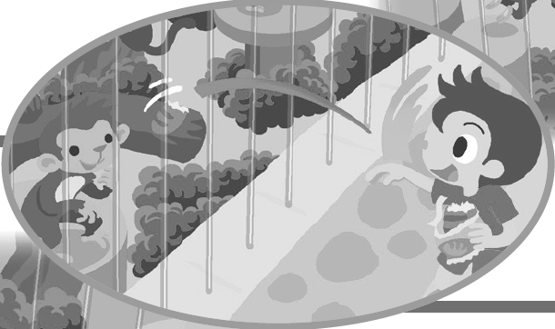
1. Situation: Leo and his family are at the zoo.
Leo is trying to feed the monkeys.
Can he do that?
¡ A. Yes, he can.
¡ B. No, he can’t.
2. Feelings and actions:
i. What may happen if the monkeys eat Leo’s food? You can choose more than one answer.
A. The monkeys may get sick.
B. Leo may get hurt.
ii. How do you feel when people don’t follow the rules?
A.  B.  C. 
2. Why are rules important at the zoo?
The rules help keep the animals [safe / quiet]. They also protect us.
3. Can you think of more rules in the zoo?


Let’s learn from the story. Circle the correct answers.
Remember to follow the rules no matter where we are. They [protect / learn] us and help make the world a better place for everyone!

Answers:

3. 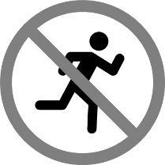 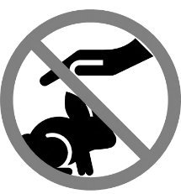(Accept any reasonable answers)

Let’s learn from the story:
Protect

Credit line:
Only Best PNG's (AI) / stock.adobe.com

