STEAM Quest Worksheet Book 5A
Spinning paper
Before the experiment
Blacken the circle of the correct answers.
Do you remember how air travels?

When air is heated, it becomes __________ and ___________ cooler air.
¡ A. heavier … sinks beneath
¡ B. lighter … rises above
¡ C. colder … rises above

My experiment
Refer to p. 63 of your Student Book for what you need and step-by-step instructions to conduct this activity. You can cut out and use the spiral on P.3 of this worksheet.

Tick () and circle your answers.
My observations

1. Did your paper spin? | o Yes, it did. o No, it didn’t.
2. How did the paper spin? | o Fast o Slow  o It didn’t spin.
3. Did using different thicknesses of paper or spiral sizes affect the result? How? | o I used [thicker / thinner] paper and it moved [slower / faster].  o I used a [bigger / smaller] spiral and it moved [slower / faster].  o I didn’t use different paper or spiral sizes.

Fill in the blanks with the correct words. There are more words than needed.
When the paper spiral is placed above the lamp, the (1) __________from the light bulb makes the air (2) __________. This rising hot air causes the paper to
(3) __________. This shows that hot air moves upwards and can move objects, just like how hot air balloons fly.
spin rise heat light
heat rise
My conclusion

My presentation
Record a video of your spinning paper design and share your results. You can use the information from My conclusion in your presentation.
Here are some useful tips when you give your presentation.
- Say your name.
- Slow down.
- Speak clearly.
- Thank the audience at the end.

My evaluation
How well do you think you did with your experiment and presentation? What have you learnt?
 | 1= Poor; 2=Fair; 3=Good; 4=Excellent
How did I do with my work? | Self-evaluation |  |  |  | Peer evaluation
I followed the experiment steps carefully. | 1 | 2 | 3 | 4 | 1 | 2 | 3 | 4
I used the materials safely and correctly. | 1 | 2 | 3 | 4 | 1 | 2 | 3 | 4
I recorded my observations clearly. | 1 | 2 | 3 | 4 | 1 | 2 | 3 | 4
I understood the results of my experiment. | 1 | 2 | 3 | 4 | 1 | 2 | 3 | 4
I explained the experiment clearly. | 1 | 2 | 3 | 4 | 1 | 2 | 3 | 4

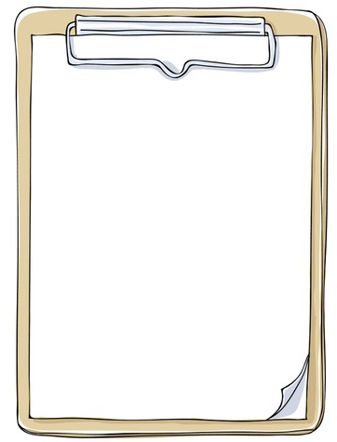
- float (verb) 漂浮（動詞）
- rise (verb) 上升（動詞）
- envelope (noun) 球囊（名詞）
- burner (noun) 燃燒器（名詞）
- basket (noun) 籃子（名詞）
- strong (adjective) 堅固的（形容詞）
- material (noun) 材料（名詞）
- passenger (noun) 乘客（名詞）
- attached (adjective) 附著的（形容詞）
- metal (noun) 金屬（名詞）
- land (verb) 著陸（動詞）
- pilot (noun) 飛行員（名詞）
- opening (noun) 開口（名詞）
- spiral (noun) 螺旋（名詞）
- thread (noun) 線（名詞）
- spin (verb) 旋轉（動詞）
- affect (verb) 影響（動詞）
- result (noun) 結果（名詞）
- design (noun) 設計（名詞）

Useful words from STEAM Quest.
Words to learn

Copy this pattern onto another piece of paper. Cut it out and use it for your experiment. You can reuse this pattern on paper with different thicknesses or resize the pattern as you like.
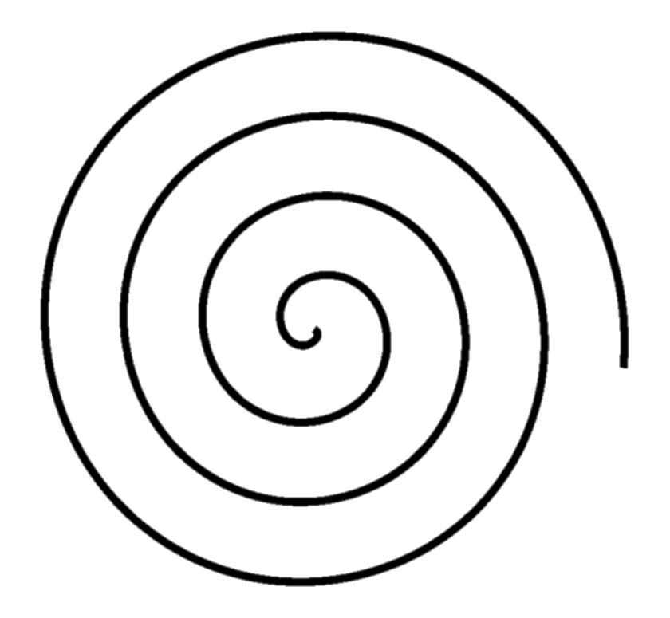

Answers:
Before the experiment:
B
Conclusion:
(1) heat
(2) rise
(3) spin

