STEAM Quest Worksheet Book 1B
Leaf art
Before the activity
Fill in the blanks with the correct words.
My leaf art
Refer to p. 63 of your Student Book for what you need and step-by-step instructions to conduct this activity. You can use a separate piece of paper to complete your leaf art.

number shapes water sizes
Do all leaves look the same?
No, leaves have different _____________ and ______________ .

My conclusion
Complete the table. You can use the words given or your own words.
tiny small big round
long heart feather hand

How many leaves do you use?
How do the leaves look like?

Which is your favourite leaf? Describe it.

My presentation
Share your leaf art with the class. Describe the leaves. Which is your favourite?
You can use the information from My conclusion in your presentation.
Here are some useful tips when you give your presentation.
- Say your name.
- Slow down.
- Speak clearly.
- Look at your classmates and teacher.
- Smile.
- Thank the audience at the end.

My evaluation
How well do you think you did with your leaf art and presentation? What have you learnt?
 | 1= Poor; 2=Fair; 3=Good; 4=Excellent
How did I do with my work? | Self-evaluation |  |  |  | Peer evaluation
I choose different leaves for my art. | 1 | 2 | 3 | 4 | 1 | 2 | 3 | 4
I use different colours for my art. | 1 | 2 | 3 | 4 | 1 | 2 | 3 | 4
I create some beautiful leaves on paper. | 1 | 2 | 3 | 4 | 1 | 2 | 3 | 4
I share my leaf art with my class. | 1 | 2 | 3 | 4 | 1 | 2 | 3 | 4

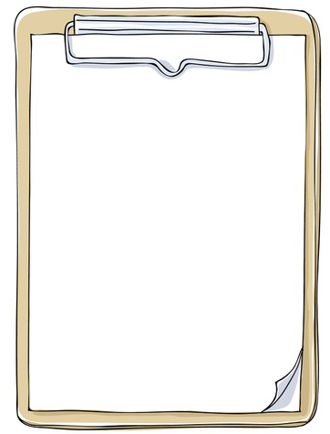

- kind (noun) 種類（名詞）
- round (adjective) 圓形的（形容詞）
- heart (noun) 心（名詞）
- feather (noun) 羽毛（名詞）
- tiny (adjective) 微細（形容詞）
- create (verb) 創造（動詞）
- crayon (noun) 蠟筆（名詞）
- pick (verb) 挑選（動詞）
- rub (verb) 擦（動詞）
- describe (verb) 描述（動詞）
Useful words from STEAM Quest.
Words to learn

Answers:
Before the experiment:
shapes … sizes // sizes … shapes

