Date: ________________
A Write the correct names in the blanks.
Kiki | Penny | Perry | Ruby
- ___________ can talk.
- ___________ has a long tail.
- ___________ sleeps a lot.
- ___________ is a penguin.

B Answer the questions. Choose the best answers.
5 This poster is about ____ .
A. small animals
B. baby animals
C. new animals at a zoo

6 ____ is a bird.
A. Kiki B. Perry C. Ruby

7 Read this sentence: They are cute. ‘They’ refers to ____ .
A. Kiki and Koko
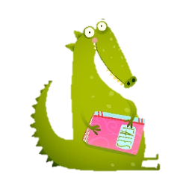
B. Penny and Poppy

C. a baby

Answers
1 Penny 2 Ruby 3 Kiki 4 Penny 5 C 6 B 7 B

